Using foxes to figure out how dogs first became domesticated

By PBS NewsHour, adapted by Newsela staff

04.05.17

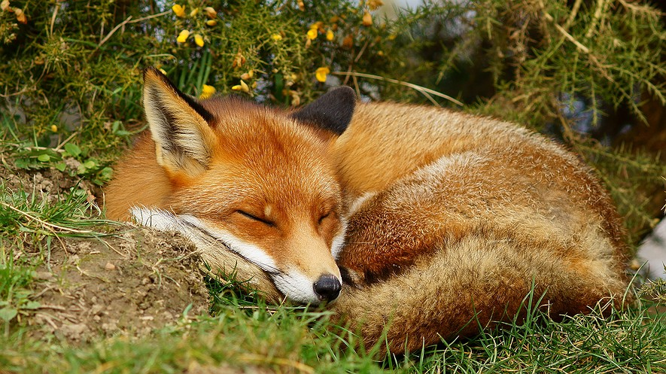A fox is pictured sleeping. Photo by: Peter Trimming/Wikimedia Commons

Cultures across the globe consider foxes to be forever wild.

In both ancient fables and big-budget movies, these fluffy mammals are depicted as being clever, intelligent and untamable. Untamable, that is, until an experiment in the Siberia area of Russia that started almost 60 years ago.

Dmitry Belyaev was studying genetics during a very dangerous time in the Soviet Union, which was a bloc of nations until they broke apart in the early nineties.

Soviet officials campaigned actively against genetic research. They used a tactic known as Lysenkoism, for which hundreds of biologists were either thrown in prison or executed.

After Soviet leader Joseph Stalin’s death in 1953, the government’s grasp on genetic research loosened. Though it was still controversial, Belyaev was finally able to test a belief he had been secretly studying.

## **Replicating The First Domesticated Dogs**

As director of a new genetics institute, Belyaev was curious about how dogs first became domesticated, or made into docile pets. So, he decided to replicate the early days of domestication.

He picked foxes for the experiment because of their similarities to dogs and purchased the tamest wild foxes he could find. The research team figured this would speed up the pace of domestication, relative to the thousands of years it took to breed dogs.

Belyaev’s team wanted to prove the foxes’ friendly behavior was the result of genetic selection, which is when traits become more common over time.

So, the researchers began to breed foxes that showed opposite traits of the tame pups. Instead of being outgoing and excited by encountering people, these foxes were defensive and aggressive. This result showed certain aspects of the fox’s behavior could be tied to genetics and spotted during breeding.

## **A Population Of Friendly Foxes**

Unfortunately, Belyaev died before seeing the final results. But today, 58 years after the start of the program, there is now a large, sustainable population of domesticated foxes. These animals have no fear of humans, and actively seek out human companionship. The most friendly are known as “elite” foxes.

“By the tenth generation, 18 percent of fox pups were elite; by the 20th, the figure had reached 35 percent,” Lyudmilla Trut, one of the researchers, wrote in a paper describing the experiment in 1999. “Today elite foxes make up 70 to 80 percent of our experimentally selected population.”

University of Illinois biologist Anna Kukekova has been studying these domesticated foxes since the late 1990s. Her lab looks at the genes behind the desirable traits in the animals.

One of the lab’s most interesting findings is that the friendly foxes show physical traits not seen in the wild, such as spots in their fur and curled tails. Their ears show weird traits, too.

Like puppies, young foxes have floppy ears. But the ears of domesticated foxes stay floppier for a longer time after birth, said Jennifer Johnson, a biologist who has worked with Kukekova since the early 2000s.

## **More Than One Gene Responsible For Behavior**

The researchers found there isn’t just one gene responsible for the friendly and outgoing behavior.

“The tameness (the nice versus mean) is actually separate from the bold animals versus the shy animals, and the active animals versus quiet animals,” Johnson said. “When these [tame and aggressive] animals are bred, we see a lot of interesting new behaviors.”

After the collapse of the Soviet Union, the domesticated fox experiment fell on hard times as public funding for the project went away. The researchers realized quickly that keeping more than 300 foxes is an expensive project. In the 1990s, the lab sold some of the foxes as fur pelts to keep the breeding program going.

Now, the lab’s primary source of money is selling the foxes to people and organizations across the globe. One customer is the Judith A. Bassett Canid Education and Conservation Center near San Diego. The center keeps six foxes — five of which are domesticated — as examples of their species, so that people can get an up-close-and-personal view of the animals.

## **Foxes Can't Be Completely Trained**

“We have a fox whose name is Boris, and as soon as someone walks in, he’ll run up to them like a dog will,” said David Bassett, president of the Conservation Center. “He wants to be scratched and if you don’t scratch him, he’ll make you.”

Want a domesticated fox of your own? Remember these rules. First, bringing one into the United States costs almost $9,000. Several states outright ban people from keeping foxes as pets, including California, New York, Texas and Oregon. And of course, while domesticated foxes are friendlier than those in the wild, they can still be unpredictable.

Even turning away for a second from a fox is risky. You do so, then realize, "Boris came up here and peed in my coffee cup,’” said Amy Bassett, the Canid Conservation Center’s founder.

You can easily train and manage behavioral problems in dogs. But, there are a lot of behaviors in foxes that you will never be able to manage, Bassett added.